**IMPORTANT – before you start doing your solution, MUST do the following steps:**

1. Create your MS SQL database named **ContactDB by running code in script**

**ContactDB.sql.**

1. Copy given file **DBContext.java (2)** to source package (src\java) folder under your web project. You might need to use and name a java package for (2), free to set the name of package.
2. **You MUST use DBContext.java for your all database connection.**
3. Set the home page/default for your project as **AddContact.jsp** page.

**Questions:**

Create a **AddContact.jsp** page with GUI as below figures **(0.5 Point)**:

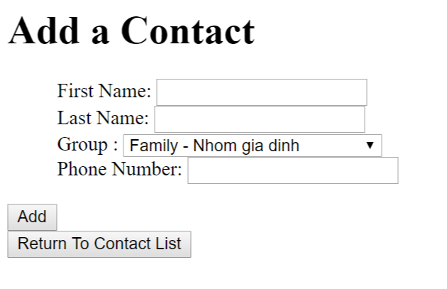

**Requirements:**

* Value for Phone Number must be numerical (**0.25 Point)**

When the users click on **Save** button, validate the data on the input form as rules:

* Require data for all text fields (**0.5 Point - 0.25 Point for each error message**).

When the validation is correct.

Add information on input form to **Contact** table (**1 Point**) and browse to **ListContacts.jsp** page **(0.25 Point)**.

When users click on the **“Return To Contact List”** button, browse to **ListContacts.jsp** page **(0.25 Point)** which will be shown as below**.**

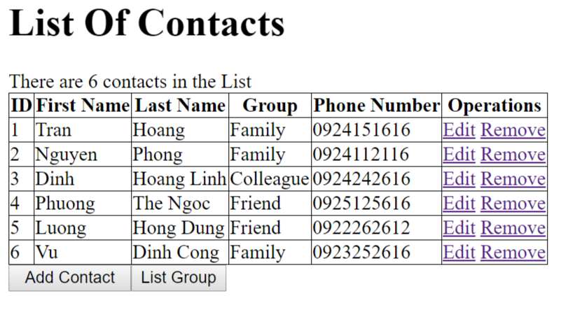

*The table must have the same columns with one in above figures.*

**Requirements:**

* Output all Contacts in Contact table to **ListContacts.jsp** as above table (**1 Point**).
* Calculate and display the number of Contacts of result **(0.25 Point).**
* Values for Groups should be corresponding to the Name of Group in Database (**0.25 Point**).

When users click on button “List Group”, browse to **ListGroups.jsp** which will output information of all groups **(1 Point)**,

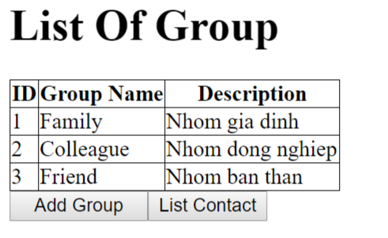

When users click on **List Contact,** browse to **ListContacts**.**jsp** page **(0.25 Point).**

When users click on **Add Group,** browse to **AddGroup.jsp** which will be used to add a new group into the database**(0.25 Point)**

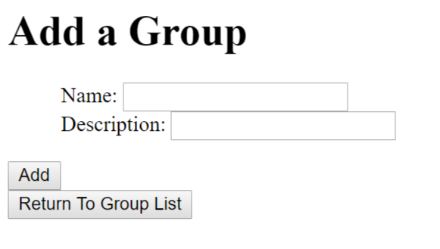

**Requirements:**

* Add information on input form to **Group** table (**1 Point**) and browse to **ListGroups.jsp** page **(0.25 Point)**.
* When users click on the **“Return To Group List”** button, browse to **ListGroups.jsp** page **(0.25 Point)** which will be shown as below**.**

On the “Contact List” page, when the users click on the link **Remove**, the corresponding record will be removed from the database, and the list will be refreshed to reflect the result. **(0.25 Point)**

When users click on the link **Edit**, browse to **EditContact.jsp** page **(0.25 Point)**

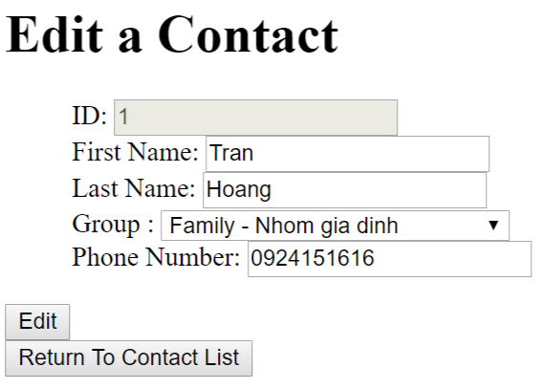

**Requirements:**

* Value for Phone Number must be numerical **(0.25 Point)**.
* Save the edited information into the database **(1 Point)**
* When user click on “Return To Contact List”, browse **ListContacts.jsp** page. **(0.25 Point)**